TechACCESS of RI
Assistive Technology Services for Children with Disabilities
Child/Student Services available:
- Evaluation/Consultation
  - Communication
  - Learning
  - Physical Access

- Training
  - Equipment
    - Hardware
    - Software
    - Devices
  - Professional Development

- Accessible Educational Materials (RIMAC)

- AAC Therapy

- Assistive Technology Tech Support
  - Hardware
  - Software
  - Devices
  - Custom Fabrication
  - Device Modification

- After School Tech Time
(See website for details)

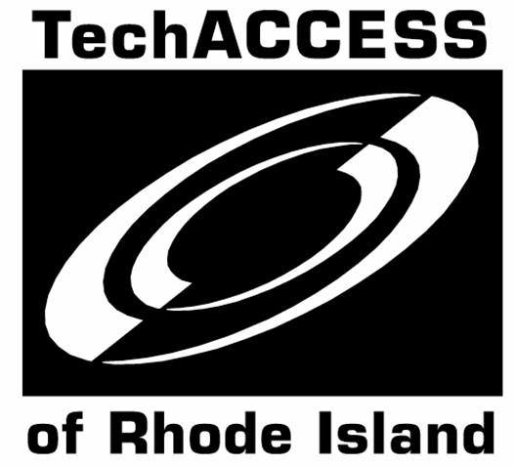



TechACCESS of RI provides Assistive Technology (AT) services for children and students from Early Intervention (Birth to3) to Grade 12 (or the age of 21). We also provide services to educational team members and families to insure that they are able to support students fully in school, the community and at home.
AT allows children to communicate (AAC), learn, navigate their environment and accomplish educational and daily living tasks, with increased independence.
Our expert staff consists of certified Speech Language Pathologists, Occupational Therapists and RESNA certified Assistive Technology Professionals.





For additional information, contact
TechACCESS of RI
(401) 463-0202
techaccess@techaccess-ri.org
www.techaccess-ri.org

TechACCESS of RI
161 Comstock Parkway
Cranston, RI 02921

